**Chroma Canvas User Manual**

**Version:** 1.0  
**Date:** [10/31/2023]

**Table of Contents**

1. Introduction
2. Getting Started
3. Explaining the Experiment
4. Setting Up the Experiment
5. Running the Experiment
6. Displaying Results
7. Creating Graphs
8. Continuing or Starting Anew
9. Conclusion

**1. Introduction**

Welcome to Chroma Canvas, a fun and educational website that allows you to experiment with colors and explore the effects of mixing different paint drops on a grid canvas. This user manual will guide you through the website's features and help you make the most of your experiments.

**2. Getting Started**

To get started with Chroma Canvas, visit our website <https://bootstrapperschromacanvas.com/>. Upon arrival, you will be greeted with an animated introduction that explains the purpose of the website. Click the "Get Started" button to begin your color mixing adventure.

**3. Explaining the Experiment**

Chroma Canvas is designed to simulate the random painting of a grid canvas using various colors. The experiment involves selecting parameters and running simulations to observe the effects of mixing paint drops. Key terms you'll encounter:

* **Independent Variable:** The factor you choose to vary in the experiment.
* **Dependent Variables:** The results you observe are based on the independent variable(s).

**4. Setting Up the Experiment**

Before you start the experiment, you'll need to set up the input settings:

* **Grid Size (X, Y):** Determine the dimensions of the grid canvas.
* **Colors (C1, C2, C3):** Choose three colors from a set of eight options.
* **Stopping Criteria (S):** Select one of three stopping criteria.
  + Every square is full.
  + A single square was double dripped on.
  + (2 x grid size) color drops have fallen.
* **Number of Repetitions (R):** Define how many times the experiment will be repeated.

Ensure to input appropriate values, and if an error occurs, a descriptive error message will guide you. For limits and justifications, refer to the documentation.

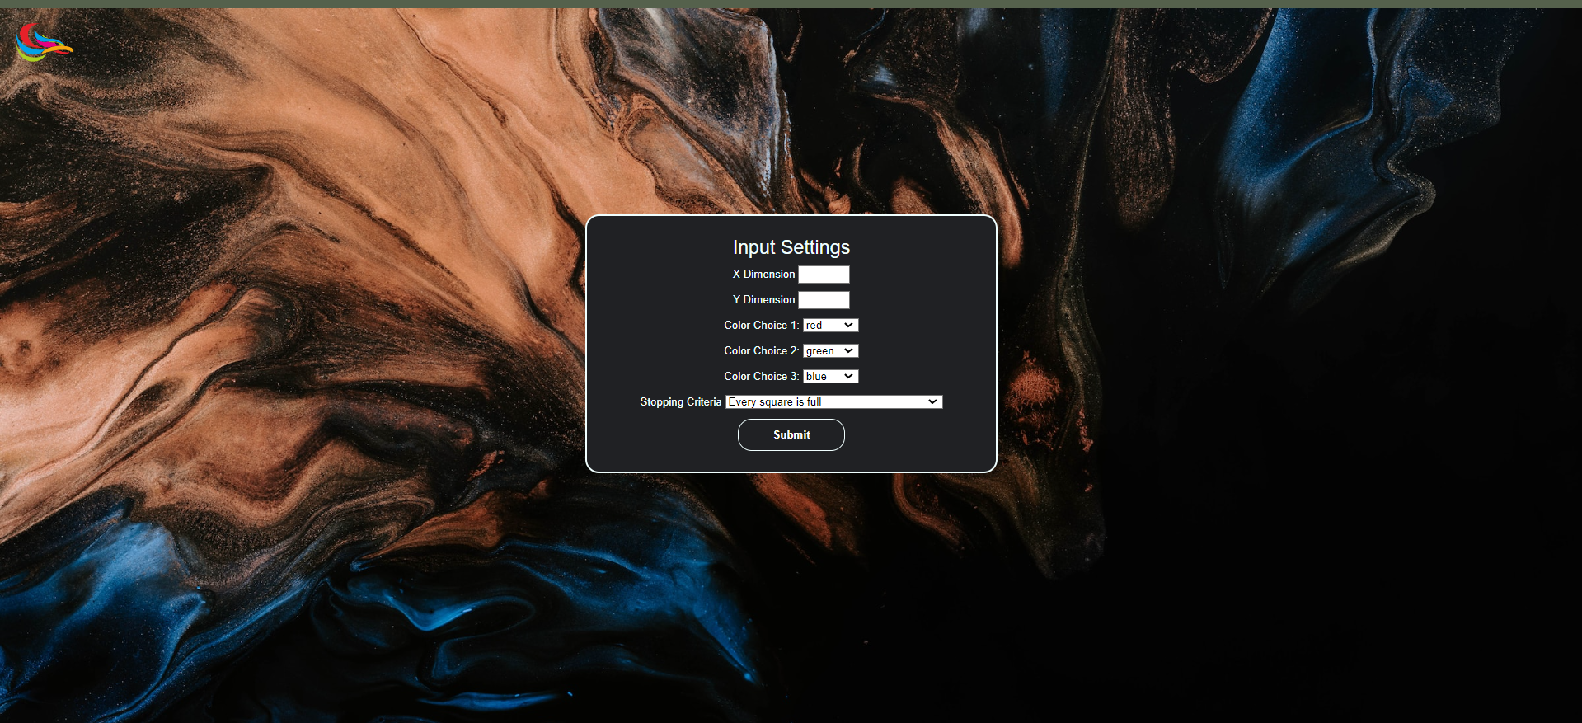

**5. Running the Experiment**

Follow these steps to run the experiment:

1. Select one of the independent variables.
   1. Single dimension for both x and y axis
   2. X dimension
   3. Number of Repetitions

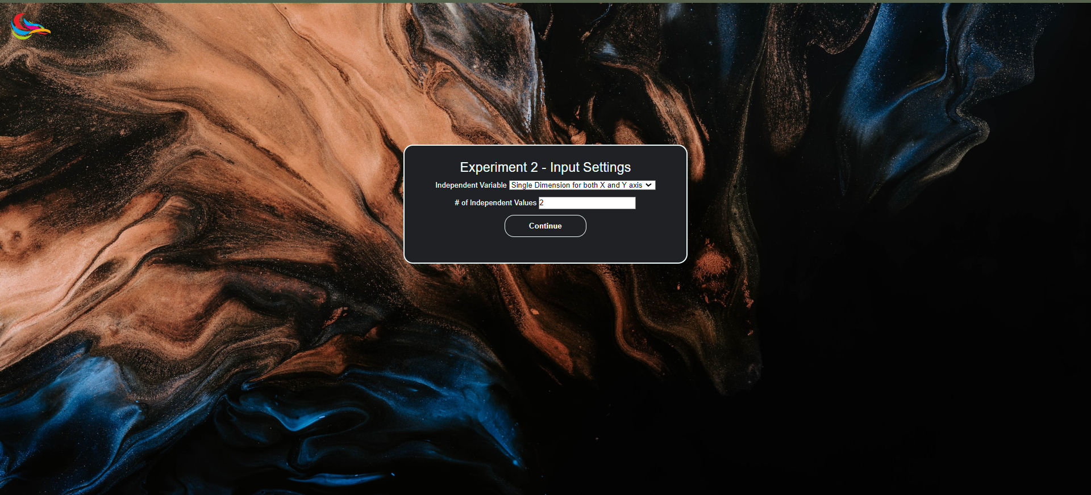

1. Provide a list of increasing values for the chosen independent variable.

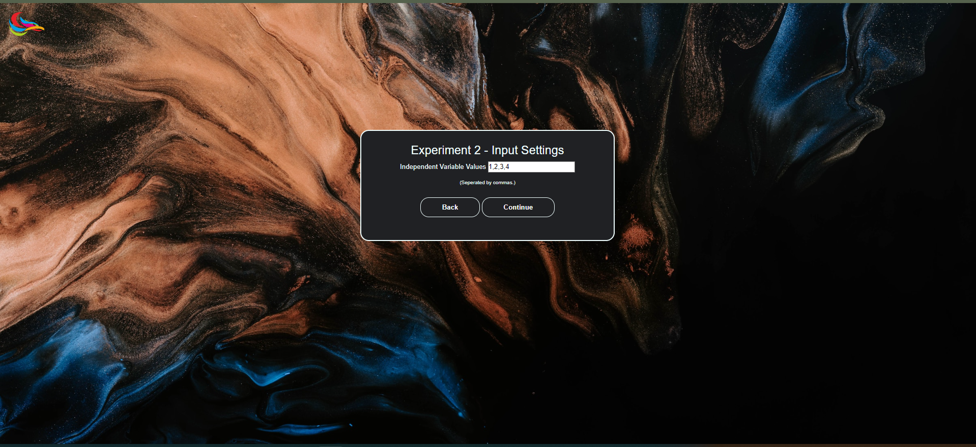

1. Set values for the remaining variables according to your choice.
2. Click "Paint”

The website will simulate painting on the grid according to your parameters. The progress will be displayed to assure you that the computations are ongoing.

**6. Displaying Results**

Once the simulations are complete, a table of results will be presented. The table includes the independent variable, fixed values, and calculated values (A, A1, A2, A3, B, and C). Use this data to analyze the outcomes.

* A: The number of paint drops put on the canvas before the painting halts
* A1. The number of paint drops on the canvas for Color 1.
* A2. The number of paint drops on the canvas for Color 2.
* A3. The number of paint drops on the canvas for Color 3.
* B: The maximum number of paint drops on any given square when the painting halts (that is, looking at all the squares, what is the largest number of paint drops that fell on one square?)
* C: The average number of paint drops over all the squares when the painting for this canvas halts

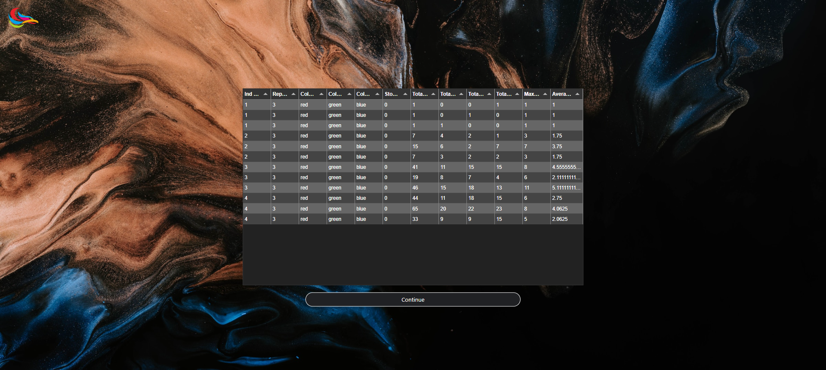

**7. Creating Graphs**

You can visualize the data by selecting one or two dependent variables from these Options,

* Total # of paint drops put on the canvas before the painting halts.
* The number of paint drops on the canvas of Color 1.
* The number of paint drops on the canvas of Color 2.
* The number of paint drops on the canvas of Color 3.
* The maximum # of paint drops on any given square when the painting halts.
* The average # of paint drops over all the squares when the painting for this canvas halts.

Click "Continue" to display a graph with the independent variable on the horizontal axis and the selected dependent variable(s) on the vertical axis. Customize the graph as needed.

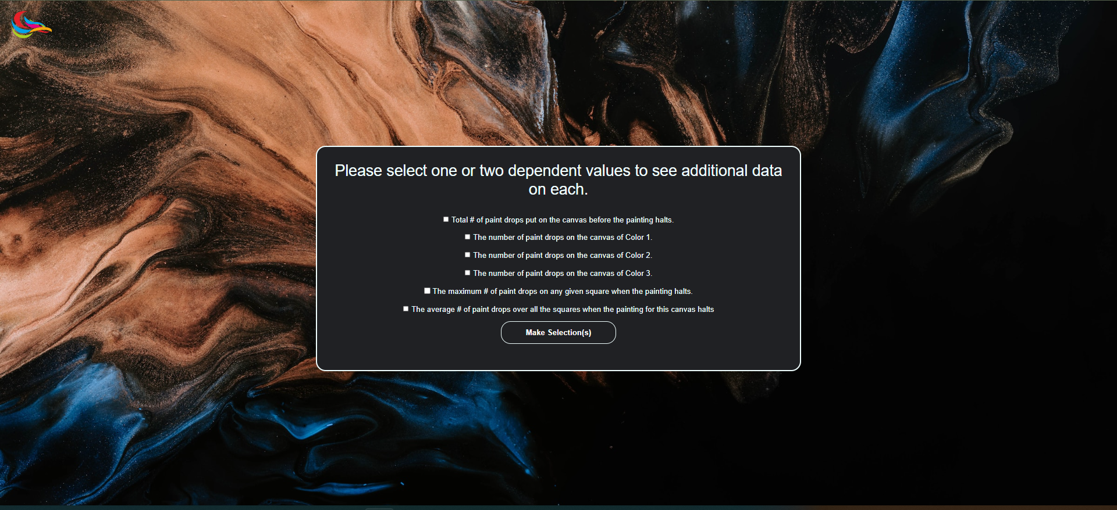

**8. Continuing or Starting Anew**

After viewing the graph, you have three options:

1. Make a new table/graph from the current data.
2. Abandon the current experiment and start a new one.
3. Quit the program.

Choose the desired option, and the website will respond accordingly.

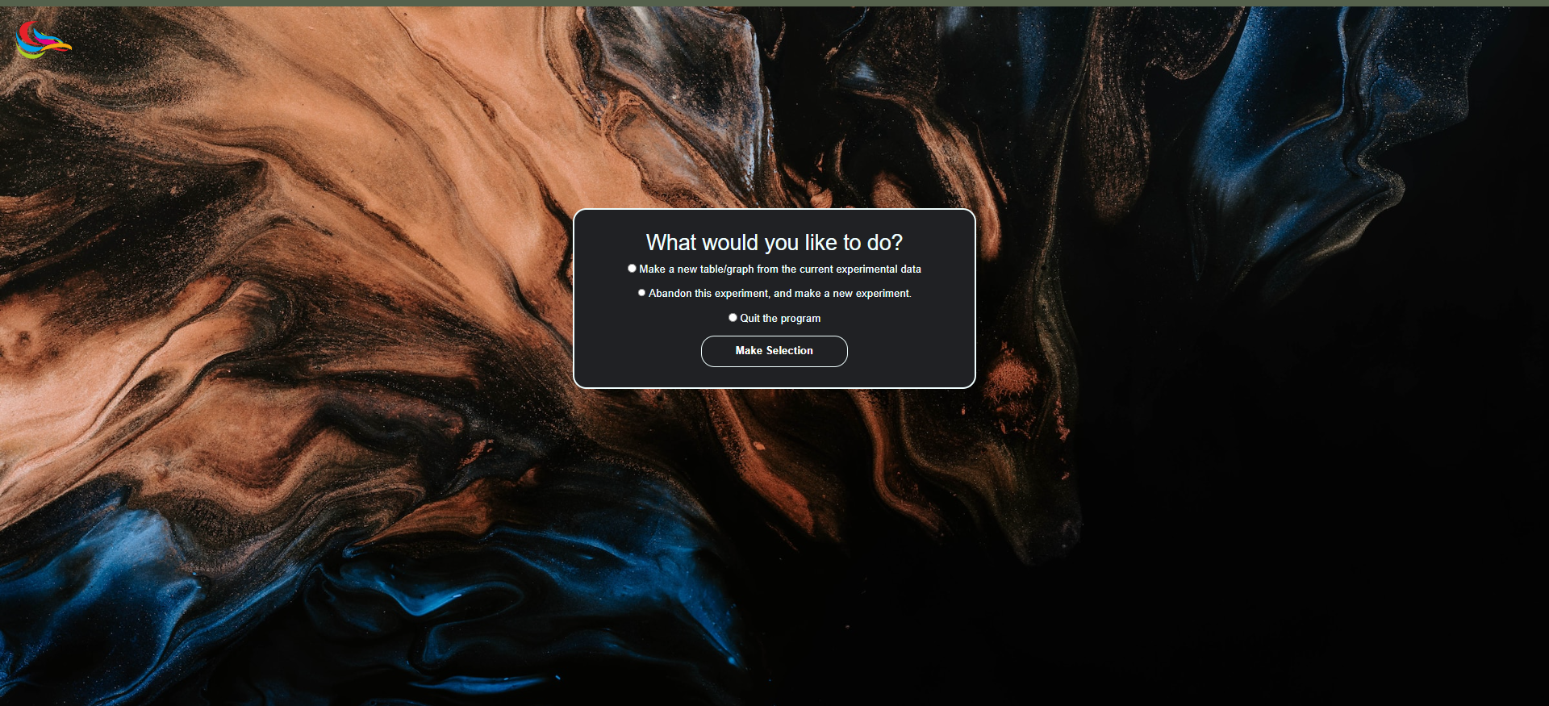

**9. Conclusion**

Thank you for using Chroma Canvas to explore color mixing experiments. We hope this user manual has helped you navigate the website effectively. Feel free to continue experimenting, and if you have any questions or encounter issues, please don't hesitate to reach out for assistance.